|  |
| --- |
| **CALCULATOR AND CONVERTER USING C**  **21CSS101J – PROGRAMMING FOR PROBLEM SOLVING**  **Mini Project Report**  *Submitted by*  **Diptayan Jash [Reg. No.: RA2211003010890]**  **B.Tech. CSE - CORE**  **Srijit Kundu [Reg. No.: RA2211003010881]**  **B.Tech. CSE - CORE**  **SRMIST-01.jpg**  **SCHOOL OF COMPUTING**  **COLLEGE OF ENGINEERING AND TECHNOLOGY**  **SRM INSTITUTE OF SCIENCE AND TECHNOLOGY**  **(Under Section 3 of UGC Act, 1956)**  S.R.M. NAGAR, KATTANKULATHUR – 603 203  KANCHEEPURAM DISTRICT  **December 2022** |

**TABLE OF CONTENTS**

|  |  |  |
| --- | --- | --- |
| **Chapter No.** | **Title** | **Page No.** |
|  | Problem Statement | 3 |
|  | Methodology/ Procedure | 3 |
|  | Algorithm | 4 |
|  | Coding (C or Python) | 5 |
|  | Output | 20 |
|  | Conclusion | 22 |

**PROBLEM STATEMENT**

Write a C program to do Calculations and Conversions.

**METHODOLOGY/PROCEDURE**

The main objective of the program is to create a simple unit converter and a calculator for the user. The unit converter and calculator developed using C language will definitely help the user to perform mathematical calculations easily and also help him/her to convert important units.

Using simple functions, if-else and switch-case constructs this calculator is designed. The user can simply enter his choice and accordingly perform the calculations with the help of the user-defined functions.

**ALGORITHM**

**Step 1:** START

**Step 2:** Declaring functions to perform various calculations and conversions

**Step 3:** Asking the user his/her choice

**Step 4:** Calling the function according to the choice by matching it with pre-defined conditions

**Step 5:** The function calculates and prints the result.

**Step 6:** END

**THE SOURCE CODE ( C )**

#include <stdio.h>

#include <stdlib.h>

#include <math.h>

#include <ctype.h>

#include <string.h>

#define MAX 1000

void addition();

void subtraction();

void multiplication();

void division();

void modulus();

void factorial();

void power();

void square();

void cube();

void squareroot();

long long convert(int oct);

void decToBinary(int n);

int main()

{

int num, binary_num, decimal_num = 0, base = 1, rem;

long int binarynum, octalnum = 0, j = 1, remainder;

long int binaryval, hexadecimalval = 0, i = 1;

int dectobin;

long k = 0;

int l = 0;

int oct;

char conti;

int category;

int tempChoice;

int currencyChoice;

int massChoice;

int userinputF; // User inputted Fahreinheit;

int userinputC; // User inputted Celsius;

int userinputUSDtoEuro; // User inputted for USD to EURO;

int userinputUSDtoJPY; // User inputted for USD to JPY;

int userinputUSDtoRMB; // User inputted for USD to RMB;

int userinputOunce; // User inputted for Ounce;

int userinputGram; // User inputted for Gram;

int fahrenheitToCelcius; // variable that stores the converted F->C;

int celciusToFahrenheit; // variable that stores the converted C->F;

float USDtoEURO; // varaible that stores the converted USD->EURO;

float USDtoJPY; // stores the converted USD->JPY;

float USDtoRMB; // stores the converted USD->RMB;

float ounceToPounds; // stores the converted Ounce->Pounds;

float gramsToPounds; // stores the conerted Grams->Pounds;

int ch;

long int octal, decimal = 0;

printf("\t\tCALCULATOR AND CONVERTER\n\n\n");

printf("\tENTER YOUR CHOICE : \n");

printf("\t1. CALCULATOR\n");

printf("\t2. CONVERTER\n");

printf("\t0. TO EXIT\n");

scanf("%d", &ch);

switch (ch)

{

case 1:

printf("\t\tWelcome to the scientific calculator!!\n\n");

int choice;

printf("\n******* Press 0 to quit the program ********\n");

printf("Enter 1 for Addition \n");

printf("Enter 2 for Subtraction \n");

printf("Enter 3 for Multiplication \n");

printf("Enter 4 for Division \n");

printf("Enter 5 for Modulus\n");

printf("Enter 6 for Power \n");

printf("Enter 7 for Factorial \n");

printf("Enter 8 for square \n");

printf("Enter 9 for cube \n");

printf("Enter 10 for squareroot\n\n");

while (1)

{

printf("\n\nEnter the operation you want to do: ");

scanf("%d", &choice);

switch (choice)

{

case 1:

addition();

break;

case 2:

subtraction();

break;

case 3:

multiplication();

break;

case 4:

division();

break;

case 5:

modulus();

break;

case 6:

power();

break;

case 7:

factorial();

break;

case 8:

square();

break;

case 9:

cube();

break;

case 10:

squareroot();

break;

case 0:

exit(0);

default:

printf("\n********** ENTER THE CORRECT CHOICE ***********\n");

}

}

break;

case 2:

printf("\t\t*************Welcome to Converter!*********** \n");

printf("\tHere is a list of conversation to choose from: \n");

printf("\t1. Temperature\n2. Currency\n3. Mass \n4. binary to decimal\n5. binary to octal\n6. binary to hexadecimal\n7. octal to binary\n8. octal to decimal\n9. decimal to binary\n");

printf("\tPlease enter the option.\n");

scanf("%d", &category);

switch (category)

{

case 1:

printf("Welcome to Temperature Converter! \n");

printf("Here is a list of conversations to choose from: \n");

printf("Enter 1 for Fahrenheit to Celsius. \n");

printf("Enter 2 for Celsius to Fahrenheit. \n");

scanf("%d", &tempChoice);

if (tempChoice == 1)

{

printf("Please enter the Fahrenheit degree: \n");

scanf("%d", &userinputF);

fahrenheitToCelcius = ((userinputF - 32) * (5.0 / 9.0));

printf("Celcius: %d", fahrenheitToCelcius);

}

else if (tempChoice == 2)

{

printf("Please enter the Celcius degree: \n");

scanf("%d", &userinputC);

celciusToFahrenheit = ((9.0 / 5.0) * userinputC + 32);

printf("Fahrenheit: %d", celciusToFahrenheit);

}

else

printf("Please enter the correct choice. \n");

break;

case 2:

printf("Welcome to Currency Converter! \n");

printf("Here is a list of conversations to choose from: \n");

printf("Enter 1 for USD to Euro. \n");

printf("Enter 2 for USD to JPY. \n");

printf("Enter 3 for USD to RMB. \n");

scanf("%d", &currencyChoice);

if (currencyChoice == 1)

{

printf("Please enter the USD amount: \n");

scanf("%d", &userinputUSDtoEuro);

USDtoEURO = userinputUSDtoEuro * 0.87;

printf("Euro: %.2f", USDtoEURO);

}

else if (currencyChoice == 2)

{

printf("Please enter the USD amount: \n");

scanf("%d", &userinputUSDtoJPY);

USDtoJPY = userinputUSDtoJPY * 111.09;

printf("JPY: %.2f", USDtoJPY);

}

else if (currencyChoice == 3)

{

printf("Please enter the USD amount: \n");

scanf("%d", &userinputUSDtoRMB);

USDtoRMB = userinputUSDtoRMB * 6.82;

printf("RMB: %.2f", USDtoRMB);

}

else

printf("Please enter correct choice. \n");

break;

case 3:

printf("Welcome to Mass Converter! \n");

printf("Here is a list of conversations to choose from: \n");

printf("Enter 1 for ounces to pounds. \n");

printf("Enter 2 for gram to pounds. \n");

scanf("%d", &massChoice);

if (massChoice == 1)

{

printf("Please enter the ounce amount: \n");

scanf("%d", &userinputOunce);

ounceToPounds = userinputOunce * 0.0625;

printf("Pounds: %.2f", ounceToPounds);

}

else if (massChoice == 2)

{

printf("Please enter the gram amount: \n");

scanf("%d", &userinputGram);

gramsToPounds = userinputGram * 0.00220462;

printf("Pounds: %.2f", gramsToPounds);

}

else

printf("Please enter the correct choice. \n");

break;

case 4:

printf(" Enter a binary number with the combination of 0s and 1s \n");

scanf(" %d", &num);

binary_num = num;

while (num > 0)

{

rem = num % 10;

decimal_num = decimal_num + rem * base;

num = num / 10;

base = base * 2;

}

printf(" The binary number is %d \t", binary_num);

printf(" \n The decimal number is %d \t", decimal_num);

break;

case 5:

printf("Enter the value for binary number: ");

scanf("%ld", &binarynum);

while (binarynum != 0)

{

remainder = binarynum % 10;

octalnum = octalnum + remainder * j;

j = j * 2;

binarynum = binarynum / 10;

}

printf("Equivalent octal value: %lo", octalnum);

break;

case 6:

printf("Enter the binary number: ");

scanf("%ld", &binaryval);

while (binaryval != 0)

{

remainder = binaryval % 10;

hexadecimalval = hexadecimalval + remainder * i;

i = i * 2;

binaryval = binaryval / 10;

}

printf("Equivalent hexadecimal value: %lX", hexadecimalval);

break;

case 7:

printf("Enter an octal number: ");

scanf("%d", &oct);

printf("%d in octal = %lld in binary", oct, convert(oct));

return 0;

break;

case 8:

printf("Enter any octal number: ");

scanf("%ld", &octal);

while (octal != 0)

{

decimal = decimal + (octal % 10) * pow(8, l++);

octal = octal / 10;

}

printf("Equivalent decimal value: %ld", decimal);

break;

case 9:

printf("ENTER DECIMAL NUMBER");

scanf("%d", &dectobin);

decToBinary(dectobin);

return 0;

break;

}

}

}

void addition()

{

printf("Enter the numbers you want to add: ");

int a, b;

scanf("%d %d", &a, &b);

printf("The sum of a and b is %d\n", a + b);

}

void subtraction()

{

printf("Enter the numbers you want to subtract: ");

int a, b;

scanf("%d%d", &a, &b);

printf("The subtraction of a and b is %d\n", a - b);

}

void multiplication()

{

printf("Enter the numbers you want to multiply: ");

int a, b;

scanf("%d%d", &a, &b);

printf("The multiplication of a and b is %d\n", a * b);

}

void division()

{

printf("Enter the numbers you want to divide: ");

int a, b;

scanf("%d%d", &a, &b);

printf("The division of a and b is %f\n", (float)a / (float)b);

}

void modulus()

{

printf("Enter the numbers you want to find modulus of: ");

int a, b;

scanf("%d%d", &a, &b);

printf("The modulus of a and b is %d\n", a % b);

}

void factorial()

{

int n, factorial;

printf("Enter the number you want the factorial of: ");

scanf("%d", &n);

factorial = 1;

for (int i = 1; i <= n; i++)

{

factorial = factorial * i; // factorial*=i;

}

printf("\nFactorial of %d is %d", n, factorial);

}

void power()

{

double b;

double p;

printf("Enter the base and the power: ");

scanf("%lf%lf", &b, &p);

double e = pow(b, p);

printf("The power is %lf", e);

}

void square()

{

double b;

printf("Enter the number you want the square of: ");

scanf("%lf", &b);

double p = pow(b, 2);

printf("The square of %lf is %lf", b, p);

}

void cube()

{

double b;

printf("Enter the number you want the cube of: ");

scanf("%lf", &b);

double p = pow(b, 3);

printf("The cube of %lf is %lf", b, p);

}

void squareroot()

{

double b;

printf("Enter the number you want the square root of : ");

scanf("%lf", &b);

double s = sqrt(b);

printf("The square root of %lf is %lf", b, s);

}

long long convert(int oct)

{

int dec = 0, i = 0;

long long bin = 0;

// converting octal to decimal

while (oct != 0)

{

dec += (oct % 10) * pow(8, i);

++i;

oct /= 10;

}

i = 1;

// converting decimal to binary

while (dec != 0)

{

bin += (dec % 2) * i;

dec /= 2;

i *= 10;

}

return bin;

}

void decToBinary(int n)

{

// array to store binary number

int binaryNum[32];

// counter for binary array

int i = 0;

while (n > 0)

{

// storing remainder in binary array

binaryNum[i] = n % 2;

n = n / 2;

i++;

}

// printing binary array in reverse order

printf("THE BINARY NUMBER : ");

for (int j = i - 1; j >= 0; j--)

printf("%d", binaryNum[j]);

}

**OUTPUT SCREEN**

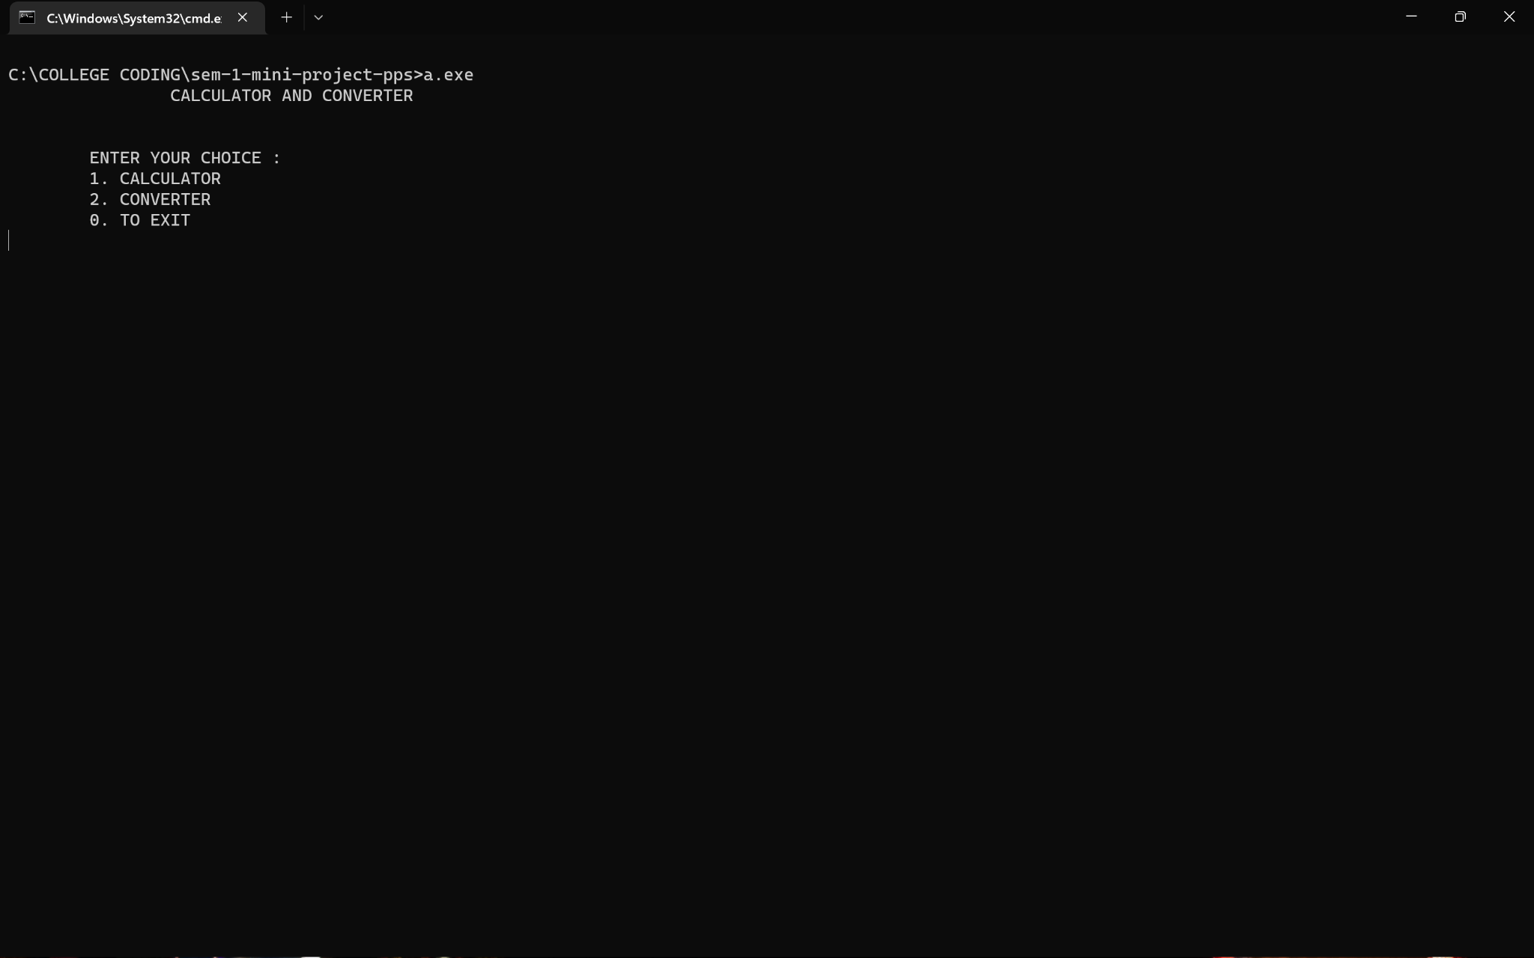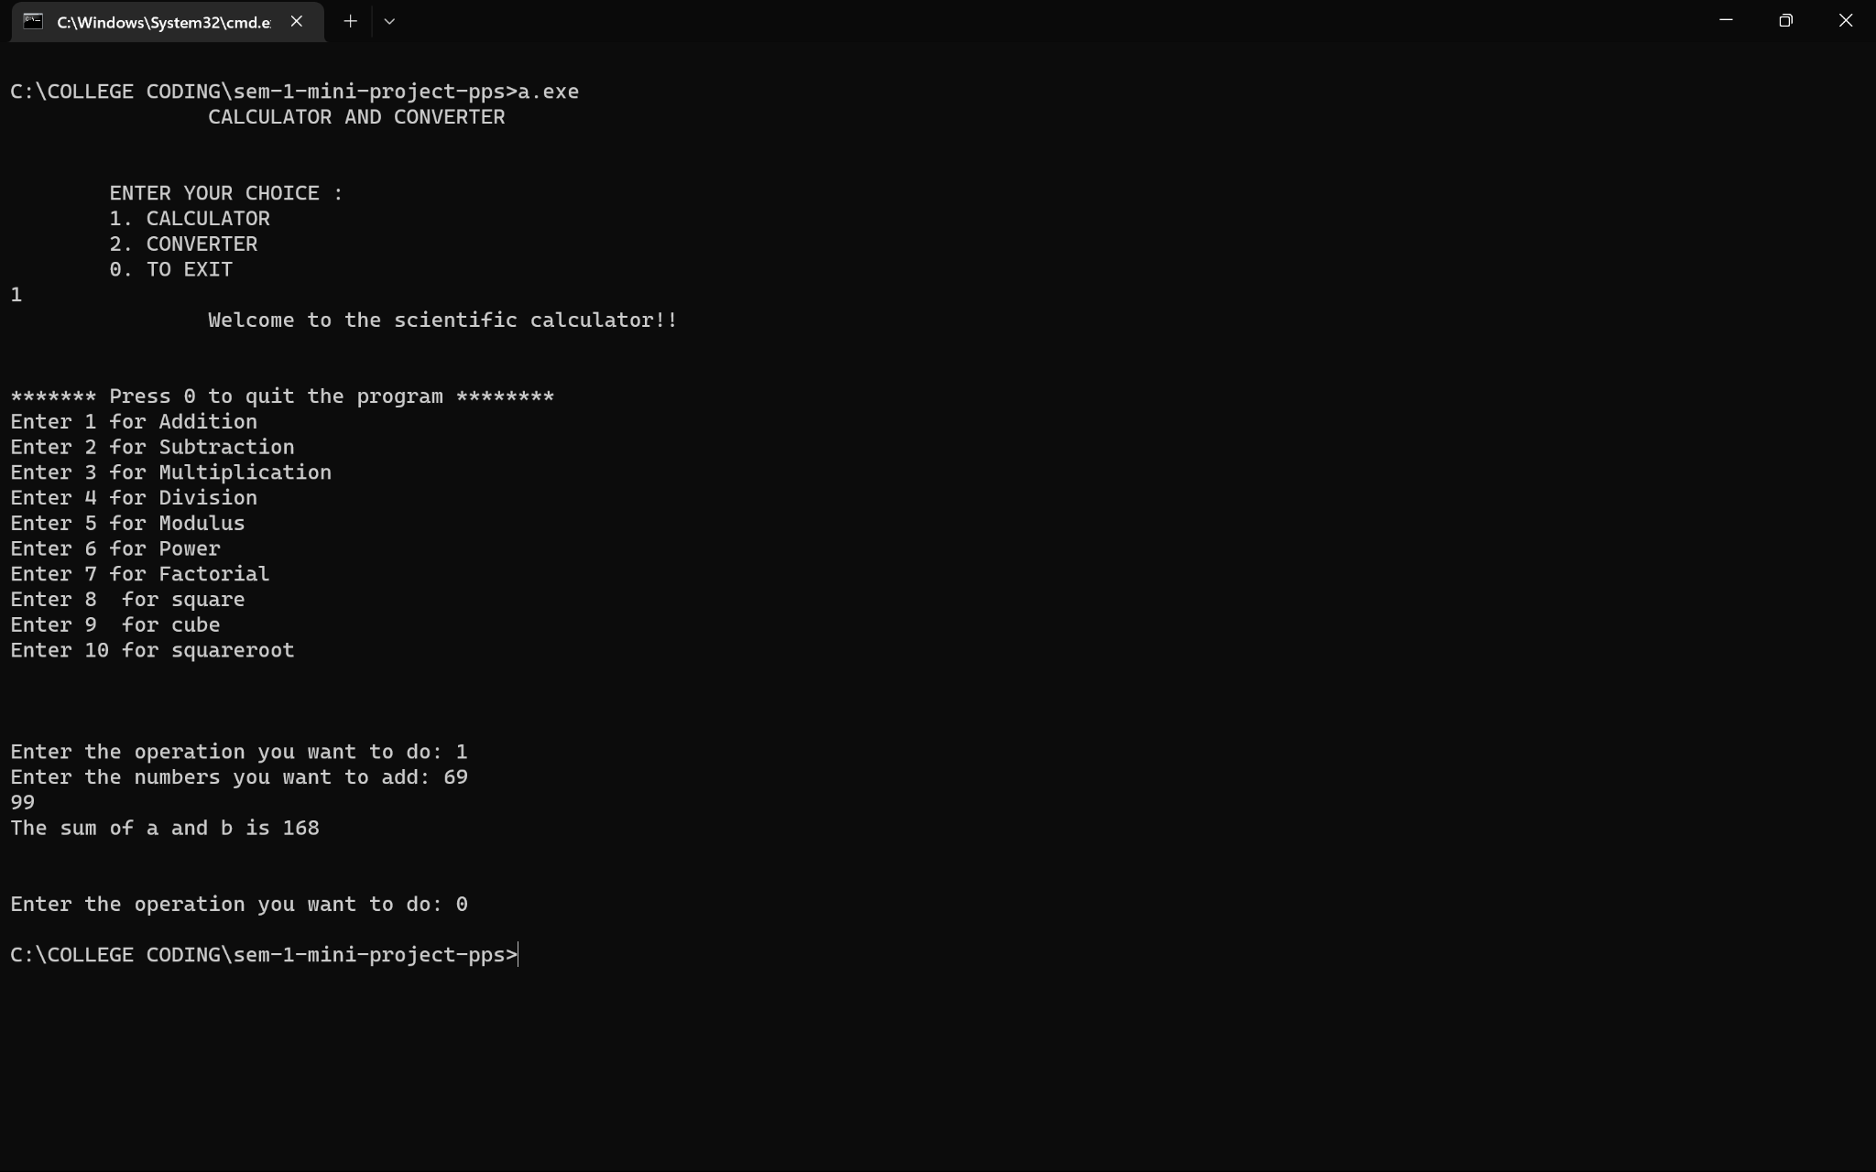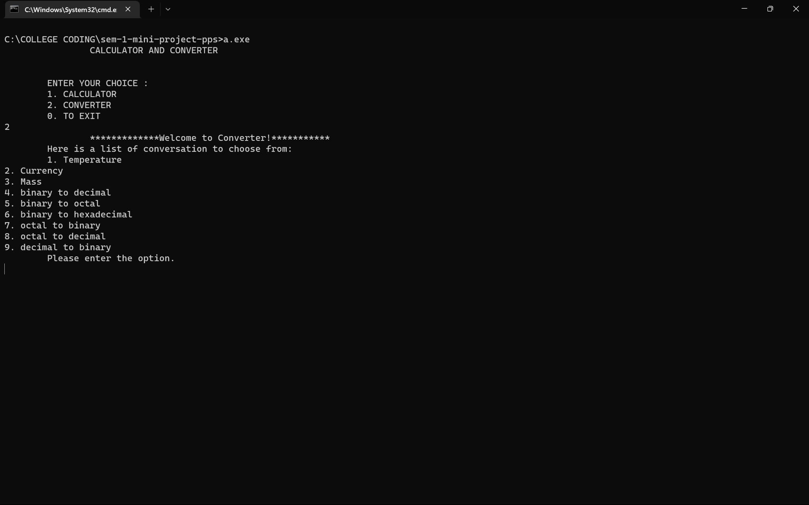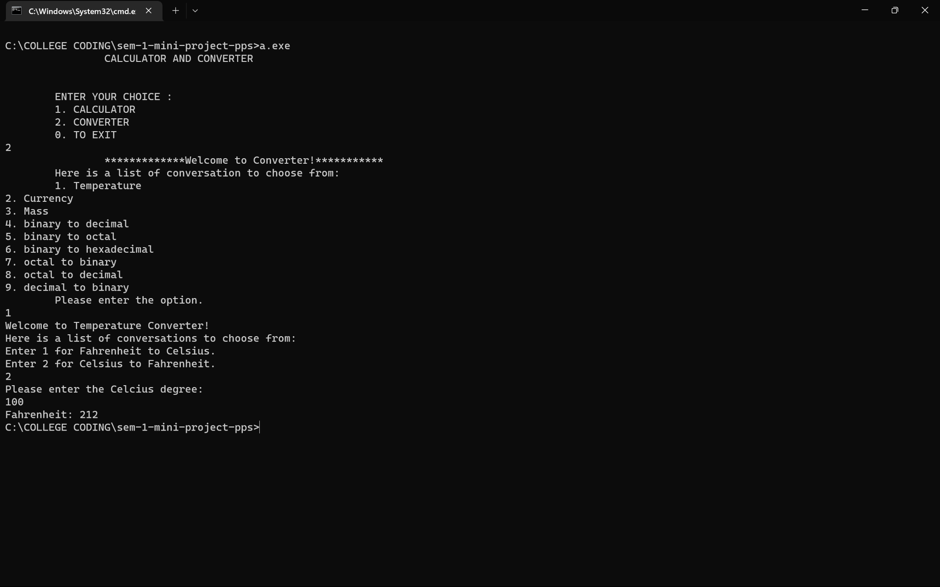

**CONCLUSION**

This project helped us to create our own program for a model calculator and convertor application from scratch using C programming. This program makes everyday calculations and conversions a piece of cake.

These tools will help us to program a code logically which will help us to create algorithms which is a very important skill for coding interviews and competitive programming.